**1. PROJECT SYNOPSIS**

## INTRODUTION:

The Courier Management System Project will have different modules; the login section will have login facility for the admin and for the user who will operate this system. While taking orders from its customers, it will take all the details of its customers who are placing the order and all the details for the recipient such as its address, name. During billing process system will generate a tracking id for their products. Through this tracking id, customers or its recipients will able to track their products from any location using internet. It will provide status of the product after placing orders within 1 minute.

 A courier delivery management system is business software that simplifies courier management and routing. A Courier Management System streamlines all of the following tasks:

* Planning and optimizing delivery
* Courier tracking and scheduling
* Analysing courier by staff
* Package tracking during delivery service
* Updating tracking details

The main objective of the Courier Management System is **to manage the details of Courier Delivery, Tracking, and Customer**. It manages all the information about Courier, Bill, user tracking details, Courier. The project is totally built at administrative end and thus only the administrator is guaranteed the access.

## INPUTS OF THE PROJECT

1. Admin Details
2. Customer details
3. Shipping details

## OUTPUT OF THE PROJECT

1. Admin Profile
2. Customer profile
3. Transaction Reports
4. Billing Reports

## 

## 1.4 PROCESS LOGIC



* 1. **TOOLS/PLATFORM**

Browser (Google Chrome)

## FRONT END

* HTML
* CSS
* BOOTSTRAP

## BACK END

* MySql

### Programming Language

* + JAVA Script
  + PHP

## DURATION OF THE PROJECT

2 Months

## MEMBERS OF THE PROJECT

**Mahmdasabir D 19M10137 Manjunath P 19M10139**

* 1. **HTML**

# FRAMEWORK

HTML means Hypertext Markup Language. HTML is a method of describing the format of document, which allows them to be viewed on computer screen. Web browsers display HTML documents, program which can navigate across networks and display a wide variety of types of information. HTML pages can be developed to be simple text or to be complex multimedia extra advantages containing, moving images, virtual reality, and java applets.

Hypertext Markup language (HTML) is used to creating the web page either of static or dynamic and used to develop the user-friendly web pages.

HTML is used for developing web pages .HTML is popularly used in World Wide Web (WWW). It uses ASCII characters for both the main text and formatting instructions the main text is data and the whole information is used by the browser to format the data. A HTML document is simply a text file, which contains certain information you would like to publish.

A set of instruction embedded in a document is called Markup Language. These instructions describe what the document text means and how it should look in a display. The language also tells you how to make a document with other document on your local systems. The World Wide Web and other inter resources such as FTP.

The global publishing format of the Internet is HTML. It allows authors to use not only text but also format that text with headings, list and tables, and also includes still images videos, and sound within text. Readers can access pages information from any where in the world at the click of mouse button information can be downloaded to readers own PC or workstations HTML pages can also be used for entering a data and as a front end for commercial transaction.

## Visual Studio Code

A website authoring program originally developed by Macromedia. It does many things including allowing designer to move back and forth between visual and HTML modes.

## PHP

PHP is a scripting language originally designed for producing dynamic webpages. It has evolved to include a command line interface capability and can be used in standalone graphical application. While PHP was originally created by RasmusLerdorf in 1995, the main implementation of PHP is now produced by the PHP Groups and serves as the de facto standard for PHP as there is no formal specification.

PHP is a scripting language under the PHP License; however, it is incompatible with the GNU General Public License (GPL). Due to restrictions on the usage of the term PHP. It is widely used general-purpose scripting language that is especially suited for web development and can be embedded into HTML. It generally runs on a web server, taking PHP code as its input, I am creating web pages as out puts. It can be deployed on web servers and on almost every operating system and platform free of charge. PHP in installed on more the twenty million web sites and one million web servers.

### PHP Architecture

**Usage**

PHP primarily acts as a filter, taking input from a file or stream containing text and/or

PHP instructions and outputs another stream of data; most commonly the output will be HTML. It can automatically detect the language of the user. From PHP 4, the PHP parser compiles input to produce byte code for processing by the Zend Engine, giving improved performance over its interpreter predecessor. Originally designed to create dynamic web pages, PHP’s principal focus is server-side scripting, and it is similar to other server-side scripting languages that provide dynamic content from a web server to a client, such as Microsoft’s Active Server

Pages, Sun Microsystems JavaServer Pages, and mod_perl. PHP has also attracted the development of many frameworks that provide building blocks and a design structure to promote rapid application development (RAD). Some of these include CakePHP, Symfony, CodeIgniter, and Zend Framework, offering features similar to other web application frameworks.

The WAMP architecture has become popular in the web industry as a way of deploying web applications. PHP is commonly used as the PHP in this bundle alongside Linux, Apache and MySQL, although they may also refer to Python or Perl. As of April 2007, over 20 million Internet domains were hosted on servers with PHP installed, and PHP was recorded as the most popular Apache module. Significant websites are written in PHP including the user-facing portion of Facebook, Wikipedia (MediaWiki), Yahoo!, MyYearbook, Wordpress.

In addition to server-side scripting, PHP can be used to create stand-alone, compiled applications and libraries, it can be used for shell scripting.

## XAMP

Stands for “Windows/Mac Apache MySQL, and PHP”. XAMP is a variation of WAMP for windows system and is often installed as a software bundle (Apache, MySQL, and PHP). It is often used for web development and internal testing but may also be used to serve live wed site.

The important part of the XAMP is Apache (or “Apache HTTP Server”) which is used to run the web server within the windows. By running the locate Apache Web Server on a Windows machine, a web developer can test web pages in a web browser with out-publishing live on the internet.

XAMP also includes MySQL and PHP, which are two of the most common technologies used for creating dynamic web sites. MySQL is a high-speed database while PHP is a scripting language that can be used to access data from data base. by installing these two components locally a developer can build and test a dynamic web site before publishing it to a public web server.

While Apache, MySQL and PHP are open-source components that can be installed individually, they are usually installed together. One popular package is called “XAMP Sever”, which provides a user-friendly way to install and configure the “AMP” components on windows.

**What is Database?**

## MY SQL

Quite simply, Its an organised collection of data. A Database management system (DBMS) such as access file maker Pro, Oracle or SQL server provides you with the software tools you need to organize that data in a flexible manner. It includes facilities to add modify or delete data from database, ask questions (or queries) about the data stored in the database and produce reports summarizing selected contents.

My SQL is a multithreaded, multi-user SQL database management system (DBMS). The basic program runs as a server providing multi-user access to several databases. My SQL was owned and sponsored by a single for-profit firm the Sidish company. My SQL now a subsidiary of Sun Micro System, which hold the copy write to most of the database. The data in My SQL is stored in database objects called Tables. A table is a collection of related data entries and consist of columns and rows. Databases are useful when storing information categorically.

**System Requirements**

**Minimum Hardware Required for project**

* + - Domain: Web Application.
    - Processor: Intel/M1 chip and above.
    - RAM: 4 GB.
    - Intel or M1 Chip or higher processor.
    - 128 GB ROM.
    - 40 GB Hard Disk.
    - Windows NT/2000/XP/MAC OS.
    - Visual Studio.

## Minimum Software Required for project FRONT END:

* + - * HTML.
      * CSS.
      * BOOTSTRAP.

## BACK END:

* MySql.

**Programming Language:** JAVA Script, PHP

# PROJECT SUBJECT

* + Speedy and efficient information processing is required to our socially and highly developed technology.
  + Computer can help the intolerable burden of handling the ever-increasing amount of information with business concerns expected to contain because of their ability to analyze information as well as to retain, update and reproduce it because of their versality to present it in a variety of forms.
  + This may also lead to problems occurring due to information explosion.

**About the project**

* + Courier management system works in every walk of our life. Through the automation of this system one can easily generate the information about the customer available and about the old records.
  + Our proposed system software can fulfill the requirements which are demanded by the customer.
  + The proposed system courier management system can manage the activities like tracking of order, giving suggestions and complaints.
  + This project includes following features: -
* Having customer information.
* For the help of user, it displays each and every detail about required orders.
* Maintains all the old record for later reference.
* Have provision for automatic update as per the status.

**Objectives of the proposed system**

1. **Immediate retrieval of information –** The main objective of the new system is to provide for quick and efficient retrieval of information, any type of information would be available to the user whenever he requires. Facility would be provided for online query to cut down on the response time greatly.
2. **Immediate storage of information –** In the proposed system, it will be easy to store information at any given time at the correct places. The location of storage would be easily available, and user will face no difficulty.
3. **Prompt updating of information –** In the proposed system, the information will always remain up to date as the updating will be prompt and without any efforts. This factor will be of great importance in the proposed system as it determines the integrity of the information stored.
4. **Fast computation of information –** The computation of information will be quite fast in the proposed system. Not only mathematical calculations, but also logical comparisons will be quick in the new system.
5. **Planned approach toward working –** The working is the service center information system will be well planned and organized. The data will be stored properly in the data store, which will help in retrieval of information as well as in its storage.
   1. **NUMBER OF MODULES**
      * Manage (Order/Staff)
6. Admin
   * + Approve Status
     + Login
     + Manage Order

* View Status
  + - Manage Staff
    - Logout

**2.Staff**

* + - Register
    - Login
* View Status
  + - My Profile
    - Logout

3.User

* Tracks the parcel.

**Module Description**

**ADMIN**

### Admin Login

The main activities in the application are the admin login page for admin. The other modules are followed by this login page. This module records only admin and password of the admin.

### Manage Orders

Admin can manage the Customer’s Order and admin can transmit the respective addresses.

### Approve status

Staff can receive the Order then admin can upload the status of approval.

## Manage Staffs and logout

An admin can manage users account and their details, status and then, the terminate the admin account

**Staff**

## Staff Login.

The main activities in the application are the user login page for user. The other modules are followed by this login page. This module records only user and password of the user.

## Staff Registration by Admin.

Another main function of our proposed system is registration, in order to register with the unique application details such as name; password, email, place and time are required.

### View status

A user can view status of Order process and Order maintenance details. User can view whole status.

### My profile and Logout

User view my profile and if the user can update the profile details and then, the terminate their account.

# SOFTWARE REQUIREMENTS SPECIFICATION

## INTRODUCTION

SRS is the official statement of what is required by the system developers; it includes both user requirements for the system and detailed specification of the system requirements. This document is used while designing the proposed system and can also be used in the future if the system is to be enhanced.

### Purpose

The purpose of this Requirements Elicitation document is to provide a clear understanding as to what actually the Industry Management Syatem is and to identify the critical requirements essential for the project’s successful completion.

This document explains our team architecture, our teams’s initial understanding of the user needs.

### Document Conventions

Main Section Title: Font: Times New Roman, Bold: Size 16 Sub Section Title: Font: Times New Roman, Bold: Size 14 Other Text Matter: Font: Times New Roman, Bold: Size 12

### Scope

This document is intended for providing an abstract overview of the system and general overview of the entire project. The scope of the document:

* + - * Team Architecture,
      * System Functional and Non-Functional Requirements
      * Prototype of the System,
      * Online payment acceptance for wide range of services.

### Reference

https://codeshoppy.com/shop/product/

<https://youtu.be/PKFczWVvrjA>

<https://studentprojectguide.com/php-projects/epost-office-management-system/>

<https://www.w3schools.com/>

## General Description

This section will give an overview of the whole application. The explanation of the application will be in its context to show the application interacts with other systems and introduce the basic functionality of it. It will also describe all the constraints and assumptions for the application.

### System Perspective

To build a customized application that facilitates to maintain the entire details of the courier service to get through the demerits of existing manual system with new implementations such as:

* + - * It takes very less time for completion of process.
      * The application and requests can be verified by the users wherever they are and can take necessary actions.
      * It is very easy for giving feedback and orders.

### Existing System

* + - * In the present system the user has to do the transaction manually.
      * It takes lot of time for transaction as they are maintaining the records in the book.

### Proposed System

The proposed system is CMS Here everything is done online. The activities like tracking can be done through online. No waiting is required. And feedbacks can be given through online. He can verify orders details online. It is very quick process than the existing system.

### Product Functionalities

Courier management Project should support the following functionalities:

* + - * Login: Sign in into the web application.
      * User : Go to the tracking page for tracking of order .
      * Admin : Look over the tracking updation in the admin panel.

### User Characteristics End Users

* + - * No specific knowledge or skills are required from the end user.
      * End user should have basic idea about computer operations.

### Administrator

* + - * Administrator must be having good knowledge of database management system.
      * Administrator must be capable to manage user rights.

## Specific Requirements

### Functional Requirements

1. **Login**
   * Start the application.
   * Admin enters the username and password.
   * System does authentication and main screen is displayed.

### Authorization Fails

* + Prompt the user that he typed the wrong password.
  + Allow him to re-enter the password.

### Change Password

* + Admin initiates the change password command.
  + Admin is prompted for to enter old password, new password and confirm password.
  + System does authentication.
  + New password is registered with the system.

### Authorization Fails

* + Prompt the Admin that he typed wrong password and allow him to re-enter.

### After the login session by admin

* + After successfully logging into the system, the Admin has to take the order details, and then update into the system for tracking for the user.
  + Admin adds the staff for more and quick updation of orders in the system.

### Other Non-Functional Requirements:

1. **Performance Requirements**
   * Should run on 500MHz, 64mb machine.
   * 90% of responses should be within 3 second, except for downloading for which more time is acceptable.

### Security Requirements

* + This application requires a user name with password is required to verify the identification of the user.

### External Interface Requirements

1. **User Interfaces**

Most user-friendly interface has been designed, Login pages for the users and admin. The main interfaces used in the system are the forms and menus.

### Hardware Interfaces

The system does not require any additional hardware interfaces, so the user need not focus on the hardware apart from the standard hardware.

### Software Interfaces

WAMP server, internet browser installed on the server machine.

# 

# 5. DESIGN OF THE SYSTEM

## Introduction

The purpose of the decision phase is to plan a solution of the problem specified by the requirements document. This phase is the first step in moving the problem domain to the solution domain. It involves the process, in which conceiving, planning and carrying out the plan generating the necessary report, In other words, the design phase act as a bridge between SRS and implementation phase. The design of the system is perhaps the most critical factor affecting the quality of the software, and as a major impact on the later phase, particularly the testing and maintenance.

### Software Design

Design is the key phase of any project. It is the first step in moving from the problem domain to the solution domain. The input to the design phase is the specifications of the system to be designed. The output of the top-level design is the architectural design, or the system design for the software system to be built. A design should be very clear, verifiable, complete, traceable, efficient and simple.

### Architecture Design

The architecture design defines the relationship among major structural element of the program. Architecture diagram shows the relationship between different components of system. This diagram helps to understand the overall concept of system.

Mysql

Xamp Server

Admin

Internet

Web Browser which manages user interaction with website

# Logical Design

The graphical representation of system data and how the process transforms the data is known as Data Flow Diagram. It shows the logical flow of the data.

The logical design describes the detailed specification for the system, describing its features, an effective communication and the user interface requirements. The logical design of proposed system should include the following.

* + 1. External system structure.
    2. Relationship between all the activities.
    3. The physical construction and all the activities.
    4. Global data.
    5. Control flow.
    6. Derived program structure.

### Design Principles

Basic design principles that enable the software engineer to navigate the design process are:

* The design process should not suffer from “Tunnel vision”.
* The design should be traceable to analysis model.
* The design should not reinvent the wheel.
* The design should minimize the intellectual distance between the software and the problem, as it exists in the real world.
* The design should exhibit uniformity and integrity.
* The design should be structured to accommodate changes.
* The design is not coding, and coding is not design.
* The design should be reviewed to minimize the conceptual errors.

## Data Flow Diagram

The data flow diagram (DFD) is one of the important modeling tools. It shows the user of the data pictorially. DFD represents the flow of the data between different transformations and processes in the systems. The data flow diagram shows logical flow of the data. It represents the functional dependencies within a system. It shows output values in a computation or derived from input values. It is a simple pictorial representation or model for system behavior. It specifies, “What is to be done but not how is to be done”. It describes the logical structure of the system. It relates data information to various processess of the system. It follows top-down approach.

### Data Flow Diagram Notations Data Flow:

It may be from file-to-file or file-to-process or process-to-process. It is generally in terms of attributes. There may be either an input data flow or output data flow.

### Functional processing



The process is nothing but the transformation of data. It starts With the subject and has the verb followed by the subject.

### Data store



It includes file, data base and repository.

### Actor/source/sink

.

The files which are outside the system and used by the process or processes of the system

### Objectives

* To graphically document boundaries of a system.
* To provide hierarchy breakdown of the system.
* To show movement of information between a system and its environment.
* To document information flows within the system.
* To aid communication between users and develop.

**Context level diagram (zero level DFD):**

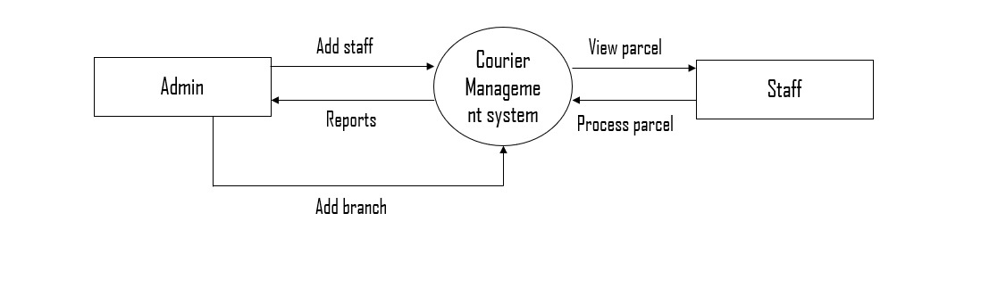

*Fig level 0 DFD:Courier management system*

### Context level diagram (one level DFD):

### 

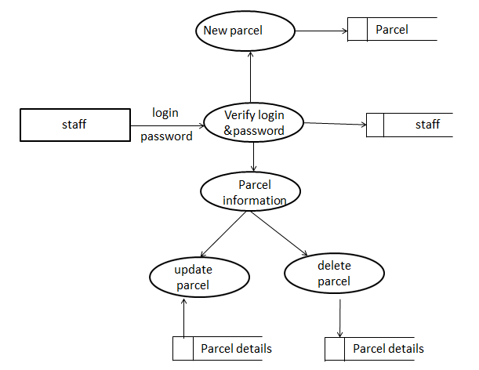

*Fig level 1 DFD: Staff*



*Fig level 1 DFD: Branch*

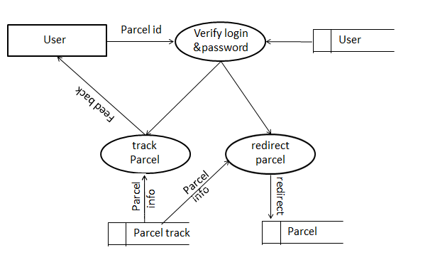

## ER Diagram

## An entity-relationship diagram is a data modelling technique that creates a graphical representation of the entities, and the relationships between entities, within an information system. An entity-relationship model (ERM) is an abstract and conceptual representation of data.

## Entity-relationship modeling is a database modelling method, used to produce a type of conceptual schema or semantic data model of a system, often a relational database, and its requirements in a top-down fashion. Diagrams created by this process are called entity relationship diagrams, ER diagrams, or ERDs.

## The first stage of information system design uses these models during the requirements analysis to describe information needs or the type of information that is to be stored in a database. The data modeling technique can be used to describe any ontology (i.e. an overview and classifications of used terms and their relationships) for a certain area of interest.

## In the case of the design of an information system that is based on a database, the conceptual data model is, at a later stage (usually called logical design), mapped to a logical data model, such as the relational model; this in turn is mapped to a physical model during physical design. Sometimes, both of these phases are referred to as "physical design".

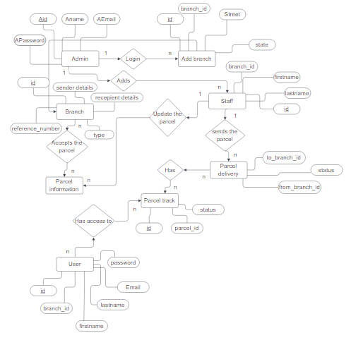

*Fig (5.3): E-R Daigram of Courier management system.*

* + - 1. **Introduction**

# IMPLEMENTATION

Implementation is the process of converting a new revised system design into operation. The objective is to put the new revised system, which has been tested into operation while holding costs, risks and personal irritation to the minimum. A critical aspect of the implementation process is to ensure that there will be no description in the function of the organization. The best methods for going control while implementation is that, any new system would be to use well planned test files for testing all new programs. Another factor to be convinced in the implementation phase in the acquisition of the hardware and software. Once the software is developed for the system and testing is carried out, it is the process of making the newly designed system fully operational and consistent in performance

### Example

<?php

Echo “WELCOME TO OUR PROJECT”

?>

### Speed optimization

As with many scripting languages, PHP scripts are normally kept as human-readable source code, even on production web servers. In this case, PHP scripts will be compiled at runtime by the PHP engine, which increases their execution time. PHP scripts are able to be compiled before runtime using PHP compilers as with other programming languages such as C (the language PHP and its extensions are written in). Code optimizers aim to reduce the computational complexity of the compiled code by reducing its size and making other changes that can reduce the execution time with the overall goal of improving performance. The nature of the PHP compilers such that there are often opportunities for code optimization, and an example of a code optimizer is the Zend Optimizer PHP extension.

Another approach for reducing overhead for high load PHP servers is using PHP accelerators. These can offer significant performance gains by caching the compiled form of a PHP script in shared memory to avoid the overhead of parsing and compiling the code every time the script runs.

### Example to display message using HTML page

<!DOCTYPE HTML PUBLIC "-//W3C//DTD HTML 4.01 Transitional//EN" ["http://www.w3](http://www.w3.org/TR/html4/loose.dtd).[org/TR/html4/loose.dtd](http://www.w3.org/TR/html4/loose.dtd)">

<html>

<head>

<meta http-equiv="Content-Type" content="text/html; charset=iso-8859-1">

<title>Untitled Document</title>

</head>

<body>

<h1>WELCOME TO OUR PROJECT</h1>

</body>

</html>

**Output**

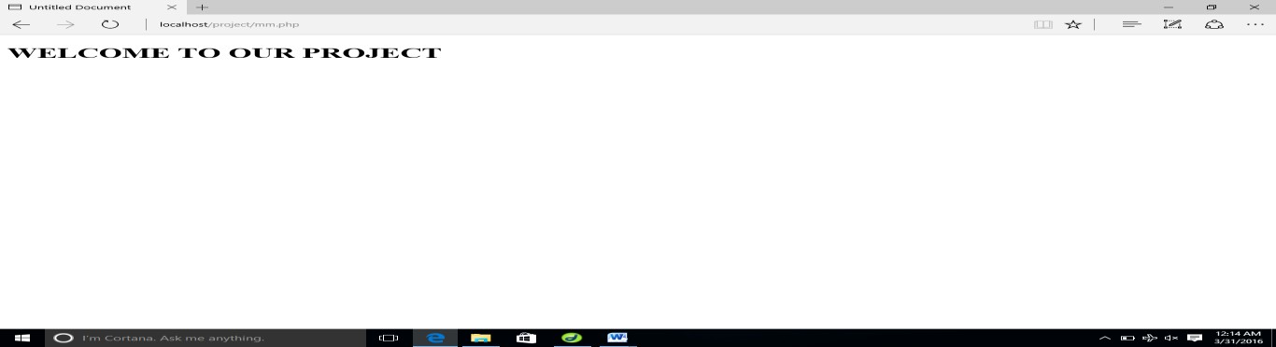

* + - 1. **Database Evolution**

SQL was invented in the year 1960’s by E. F. Cod of IBM in order to increase data integrity and reduce repetitive data. RDBMS did not appear until the late 70’s when Sybase and Oracle introduced systems.

SQL server was originally a Sybase product. Microsoft bought the product outright from Sybase and by version 7.0, the version prior to 2000 all the code had been rewritten by Microsoft’s programming.

### Features of SQL

* + - * + The entire SQL has been divided into 4 major categories

1. Data Manipulation Language.
2. Data Definition Language.
3. Transaction control language.
4. Data Control Lnaguage.

* It is simple English like language and uses simple commands such as SELECT, CREATE, DROP etc.
* It is not having conditional loops, variables and most of the commands are single line commands.
* To implement application logics, SQL has got extension language popularly called as PL/SQL (Procedural language of SQL).
* One of the key features of sql server is the XML support. XML has grown to be standard technology for organizations that share data on the web.

### Security

Views are basically used as a part of security, means in many organizations end user will never be given original tables and all data entry will be done with the help of views only. But the database administrator will be able to see everything because all the operations done by the different users will come to the same table.

### Queries

A query is a question or a request. With MySql, we can query a database for specific information and have a record set returned.

### Create a connection to a database

Before you can access data in a database, you must create a connection to the database. In PHP, this is done with the mysql_connect () function.

### Syntax

Mysql connect (server name, username, password); Server name: Optional Specifies the Server to connect. Default values is localhost: 3306

<?php

$con=mysql_connect('localhost','root',''); mysql_select_db ('project', $con); ?>

### Steps to create a database in PHPMyAdmin

1. 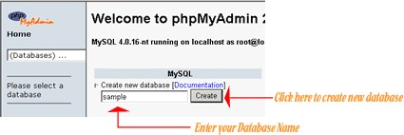The following figure shows your PHPMyAdmin interface, just enter your database name and click the 'Create' button to create your database.
2. Now to create a new table enter your table name and the number of fields in the table, then click the 'Go' Button.

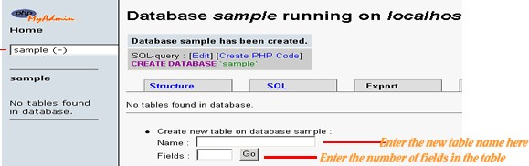

1. The next step is to create the fields, just enter values for each field name, type, length of the field, null option and mention whether it is a primary key or not. Then click the 'Save' button to complete your table creation.

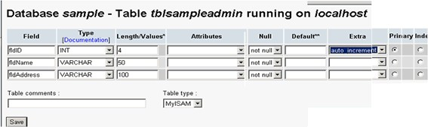

1. The following figure is displayed upon successful creation of your table

### Steps to Drop Table in PHPMyAdmin

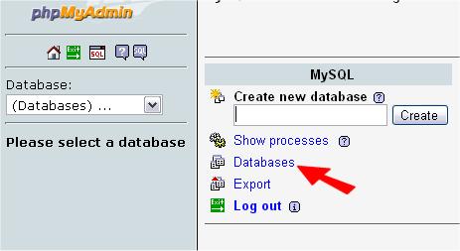Login to phpmyadmin. Click 'databases'

List of your databases will appear. Click the one that is your WordPress database.

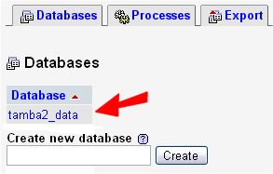

Note the size of the 'wp_bad_behaviour_log' table - this is one to be emptied in this example.

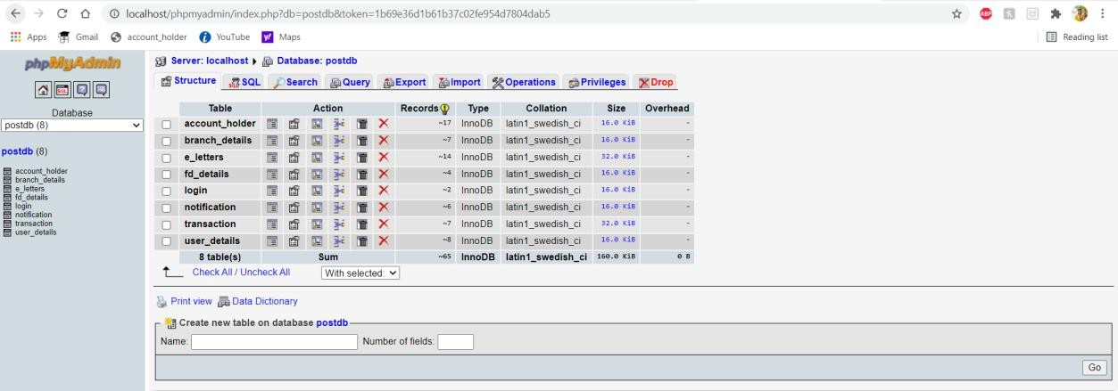

Now select the box to the left of the table you wish to empty.

Note: Your table may have a different name, and unless you have been told, do NOT empty a table that is used by the Word Press core.

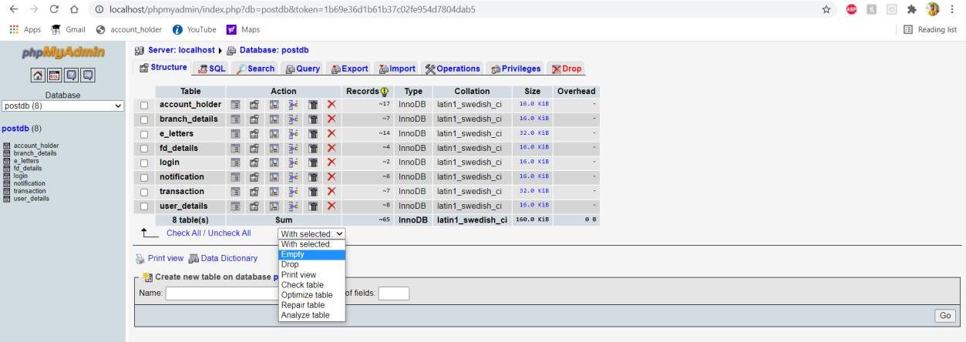

From the drop-down menu, highlight and click the 'Empty' option. You will now get a confirmation screen.

This is your last chance to check - there is no 'UNDO' function here!

Click 'Yes' and you will be returned to viewing all the tables in your install. And your table has been cleared out.

If you needed to Drop a table, follow exactly the same, but select 'Drop' from the menu.

# DATABASE TABLES

## 7.1 Tables Used In Our Project

**Table structure for Branches table Primary Key:** id

|  |  |  |  |
| --- | --- | --- | --- |
| **Field** | **Type** | **Null** | **Default** |
| ***Id*** | Int (30) | No | NULL |
| branch_code | Varchar(50) | No | NULL |
| Street | text | No | NULL |
| City | text | No | NULL |
| State | text | No | NULL |
| zip_code | int(50) | No | NULL |
| Country | text | No | NULL |
| Contact | Int(100) | No | NULL |
| date_created | datetime | No | current_timestamp |

### Table structure for parcel_track table Primary Key: id

|  |  |  |  |
| --- | --- | --- | --- |
| **Field** | **Type** | **Null** | **Default** |
| ***Id*** | Int (30) | No | NULL |
| parcel_id | Int(30) | No | NULL |
| Status | Int(2) | No | NULL |
| date_created | datetime | No | current_timestamp |

**Table structure for parcels table Primary Key:** id

|  |  |  |  |
| --- | --- | --- | --- |
| **Field** | **Type** | **Null** | **Default** |
| ***Id*** | Int (30) | No | NULL |
| reference_number | varchar(100) | No | NULL |
| sender_name | text | No | NULL |
| sender_address | text | No | NULL |
| sender_contact | text | No | NULL |
| reciepient_name | text | No | NULL |
| reciepient_address | text | No | NULL |
| reciepient_contact | text | No | NULL |
| Type | Int(1) | No | NULL |
| from_branch_id | varchar (30) | No | NULL |
| to_branch_id | varchar (30) | No | NULL |
| Weight | varchar (100) | No | NULL |
| Height | varchar (100) | No | NULL |
| Width | varchar (100) | No | NULL |
| Length | varchar (100) | No | NULL |
| Price | float | No | NULL |
| Status | Int(2) | No | NULL |
| date_created | datetime | No | current_timestamp |

### Table structure for System table Primary Key: id

|  |  |  |  |
| --- | --- | --- | --- |
| **Field** | **Type** | **Null** | **Default** |
| ***Id*** | Int (30) | No | NULL |
| Name | text | No | NULL |
| Email | varchar(200) | No | NULL |
| Contact | varchar(20) | No | NULL |
| Address | text | No | NULL |
| Cover_img | text | No | NULL |

**Table structure for users/staff table Primary Key:** id

|  |  |  |  |
| --- | --- | --- | --- |
| **Field** | **Type** | **Null** | **Default** |
| ***Id*** | Int (30) | No | NULL |
| Firstname | varchar (200) | No | NULL |
| Lastname | varchar (200) | No | NULL |
| Email | varchar (200) | No | NULL |
| Password | text | No | NULL |
| Type | tinyint(1) | No | NULL |
| Branch_id | Int(30) | No | NULL |
| Date_created | datetime | No | current_timestamp |

# SCREEN SHOTS

### Fig 1. A VIEW OF HOMEPAGE



**Fig 2. A VIEW OF LOGIN PAGE**

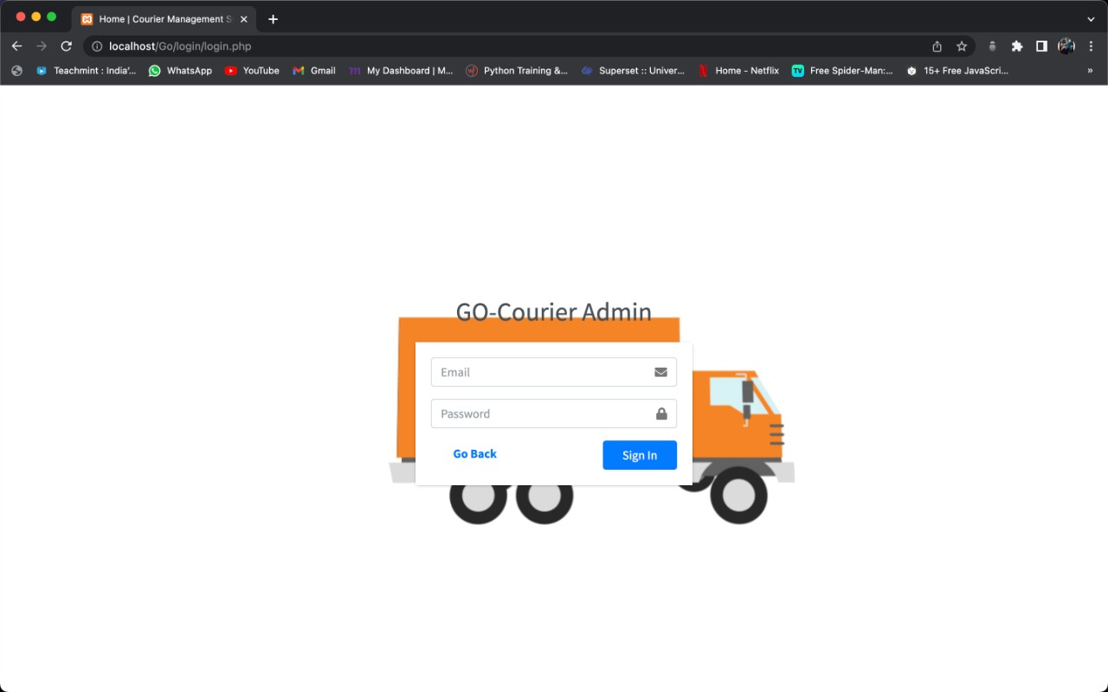

### Fig 3. A VIEW OF TRACKING PAGE

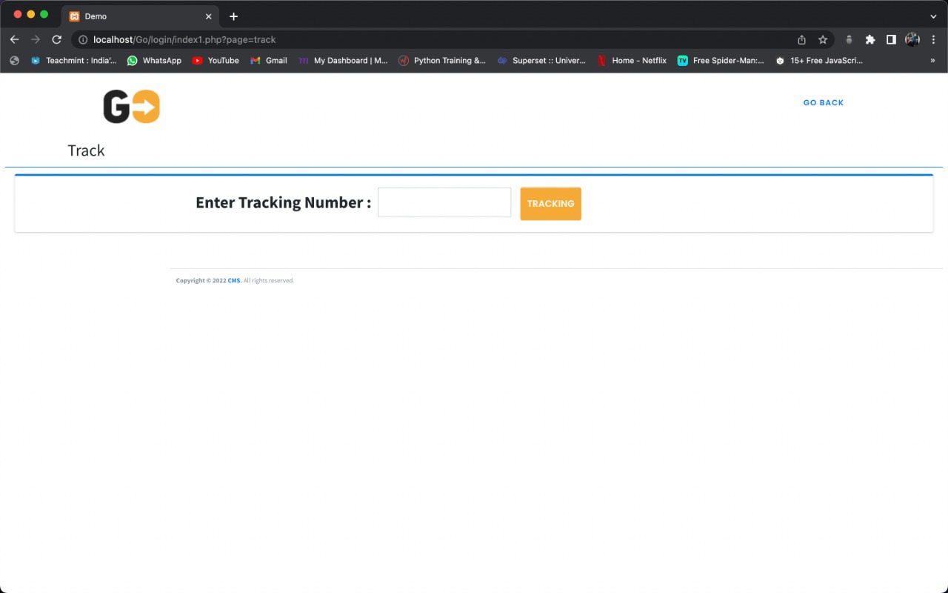

**Fig 4. A VIEW OF ADMIN DASHBOARD**

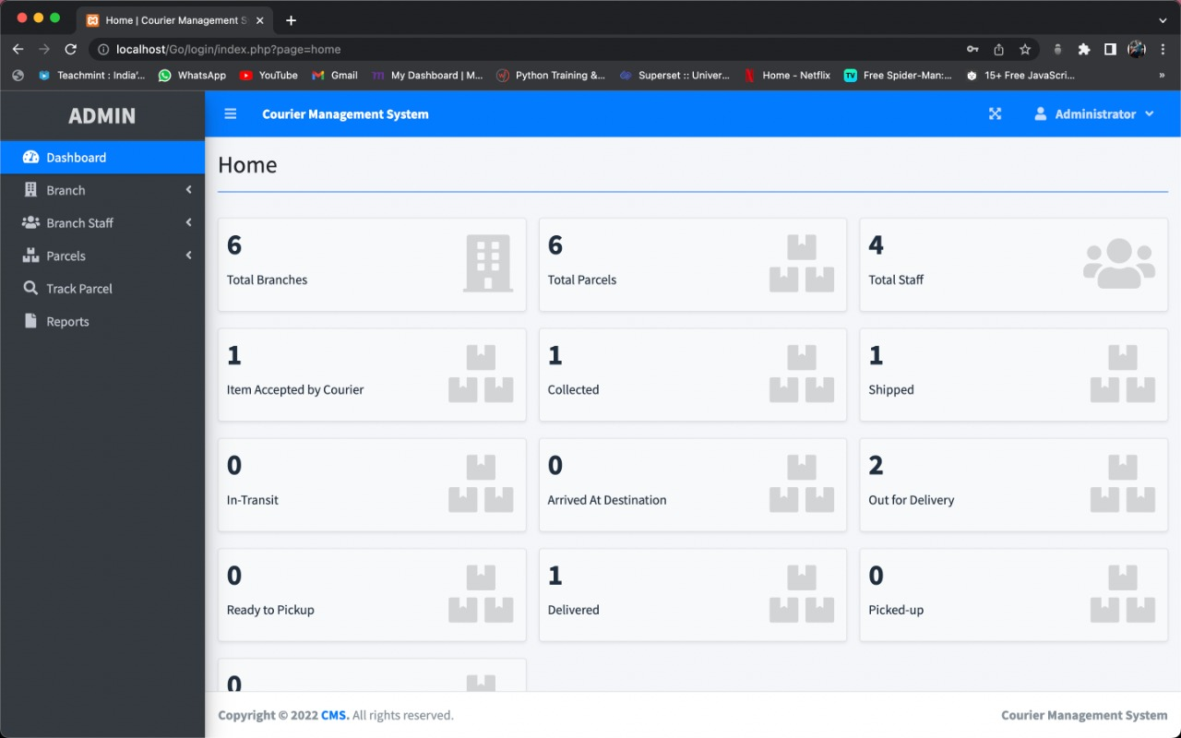

### Fig 5. A VIEW OF BRANCH TABLE

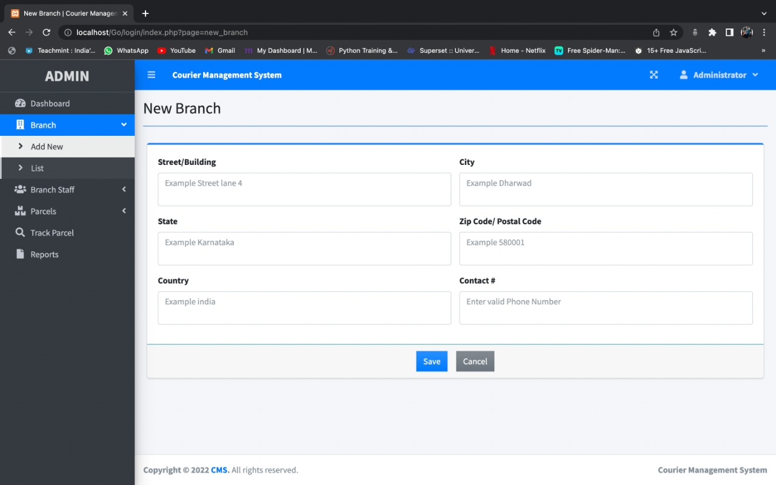

**Fig 6. A VIEW OF STAFF TABLE**

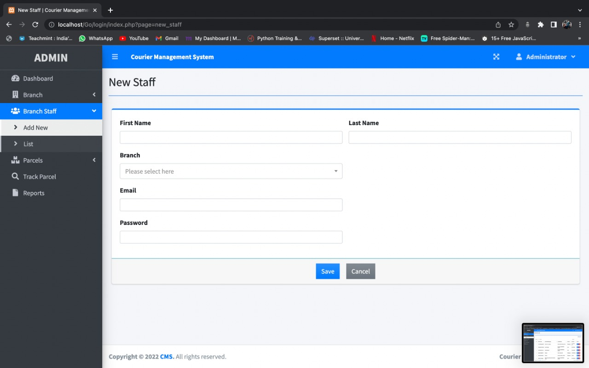

### Fig 7. A VIEW OF BRANCH LIST TABLE

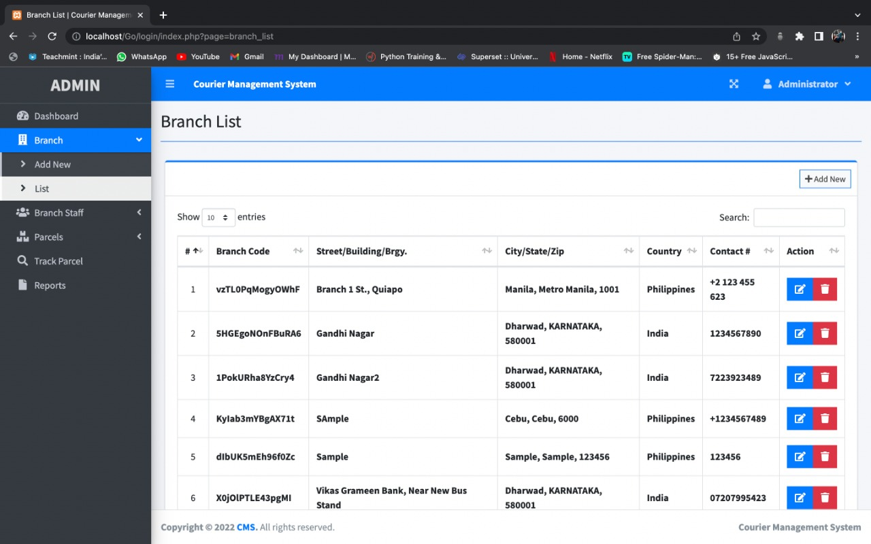

**Fig 8. A VIEW OF STAFF LIST TABLE**

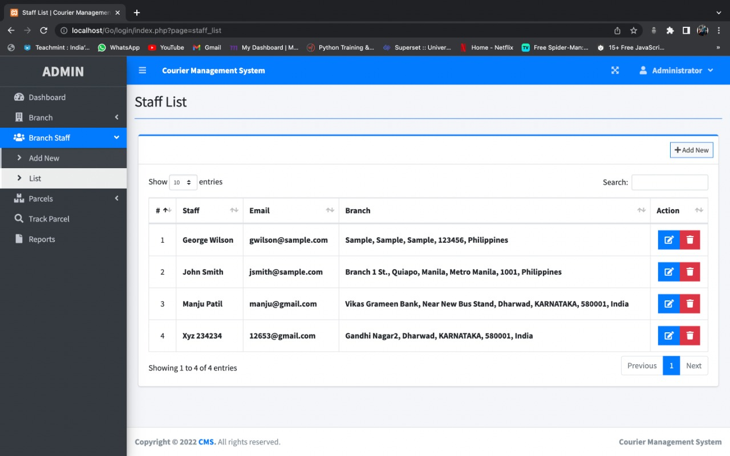

### Fig 9. A VIEW OF PARCEL DETAILS TABLE

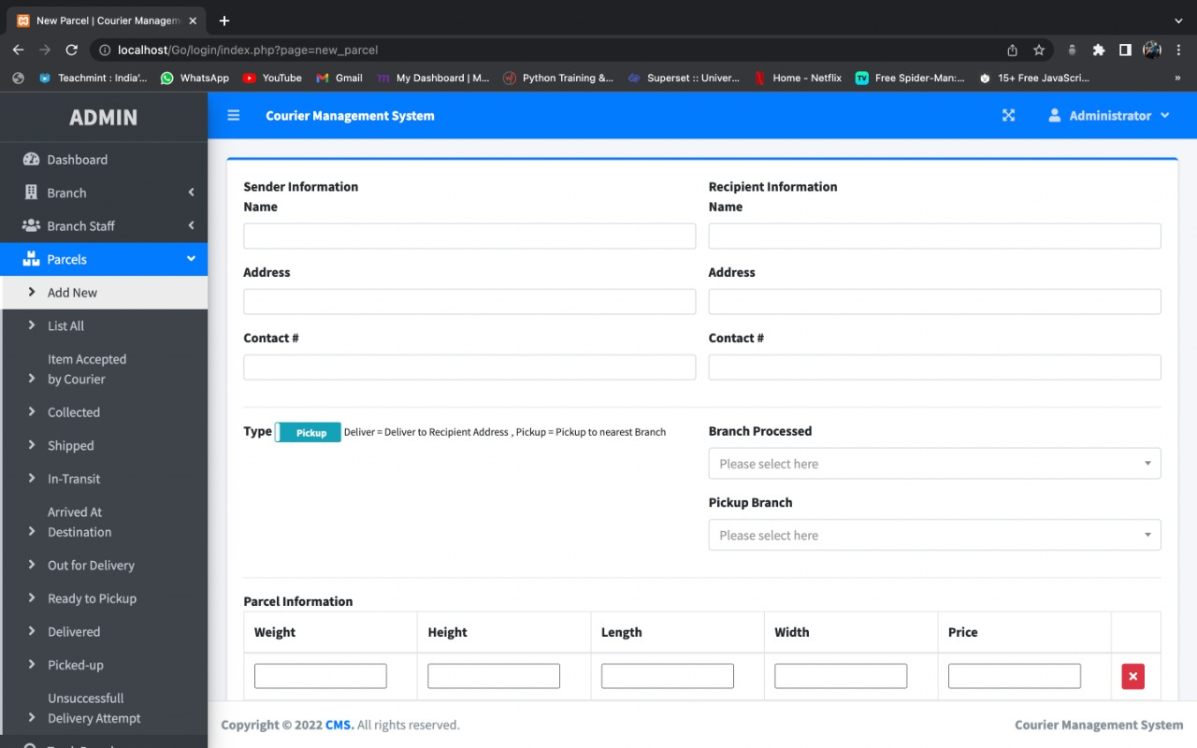

**Fig 10. A VIEW OF PARCEL TABLE**

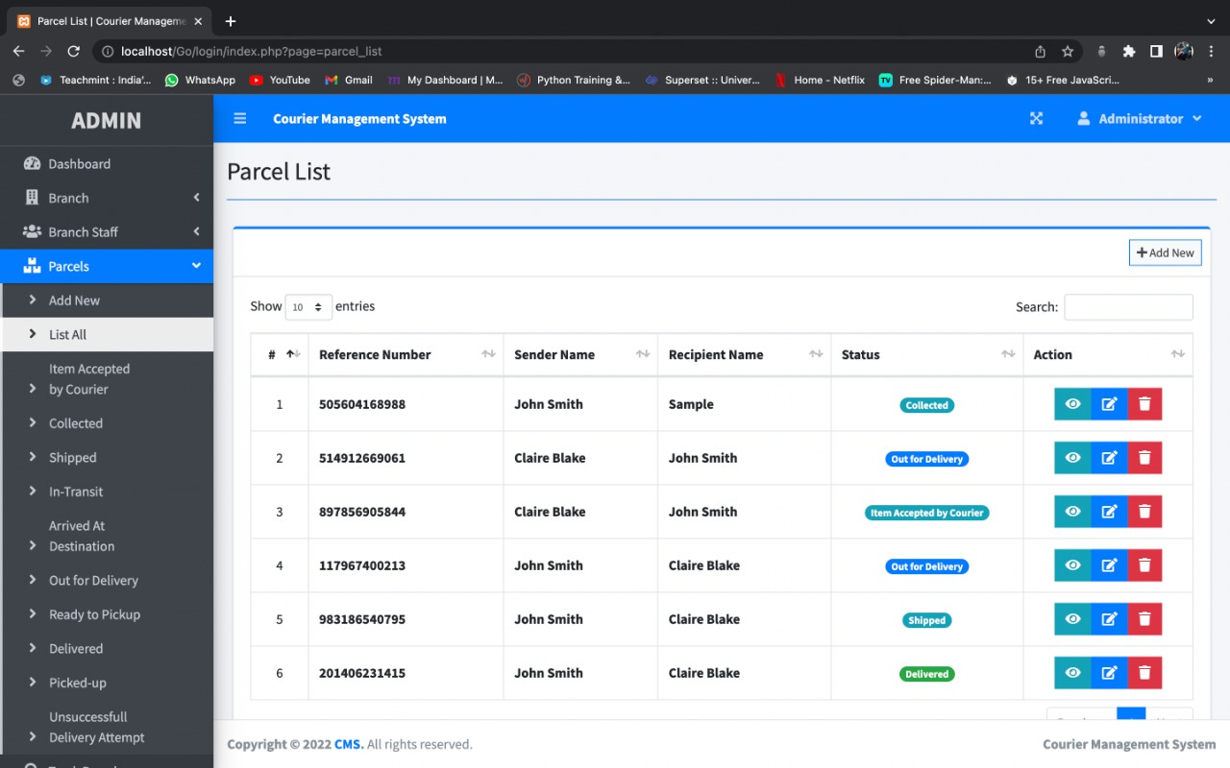

# SOURCE CODE

**ACCOUNT HOLDER**

## HOME

## <!DOCTYPE html>

## <html>

## <head>

## <title>GO COURIER</title>

## <meta charset="UTF-8">

## <meta name="viewport" content="width=device-width, initial-scale=1.0">

## <!-- Bootstrap Css -->

## <link rel="stylesheet" type="text/css" href="assets/plugins/bootstrap-3.3.6/css/bootstrap.min.css">

## <!-- Bootstrap Select Css -->

## <link rel="stylesheet" type="text/css"

## href="assets/plugins/bootstrap-select-1.10.0/dist/css/bootstrap-select.min.css">

## <!-- Fonts Css -->

## <link rel="stylesheet" type="text/css" href="assets/plugins/font-awesome-4.6.1/css/font-awesome.min.css">

## <link rel="stylesheet" type="text/css" href="assets/plugins/font-elegant/elegant.css">

## <!-- OwlCarousel2 Slider Css -->

## <link rel="stylesheet" type="text/css" href="assets/plugins/owl.carousel.2/assets/owl.carousel.css">

## <!-- Animate Css -->

## <link rel="stylesheet" type="text/css" href="assets/css/animate.css">

## <!-- Main Css -->

## <link rel="stylesheet" type="text/css" href="assets/css/theme.css">

## <!--[if lt IE 9]>

## <script src="assets/plugins/iesupport/html5shiv.js"></script>

## <script src="assets/plugins/iesupport/respond.js"></script>

## <![endif]-->

## </head>

## <body id="home">

## <!-- Preloader -->

## <div id="preloader">

## <div class="small1">

## <div class="small ball smallball1"></div>

## <div class="small ball smallball2"></div>

## <div class="small ball smallball3"></div>

## <div class="small ball smallball4"></div>

## </div>

## <div class="small2">

## <div class="small ball smallball5"></div>

## <div class="small ball smallball6"></div>

## <div class="small ball smallball7"></div>

## <div class="small ball smallball8"></div>

## </div>

## <div class="bigcon">

## <div class="big ball"></div>

## </div>

## </div>

## <!-- /.Preloader -->

## <!-- Main Wrapper -->

## <main class="wrapper">

## <!-- Header -->

## <?php include'menu.php'?>

## </header>

## <!-- /.Header -->

## <!-- Content Wrapper -->

## <article>

## <!-- Banner -->

## <section class="banner mask-overlay pad-120 white-clr">

## <div class="container theme-container rel-div">

## <img class="pt-10 effect animated fadeInLeft" alt="" src="assets/img/icons/icon-1.png" />

## <ul class="list-items fw-600 effect animated wow fadeInUp" data-wow-offset="50"

## data-wow-delay=".20s">

## <li><a href="#">fast</a></li>

## <li><a href="#">secured</a></li>

## <li><a href="#">worldwide</a></li>

## </ul>

## <h2 class="section-title fs-48 effect animated wow fadeInUp" data-wow-offset="50"

## data-wow-delay=".20s"> awesome website for <br> <span class="theme-clr"> courier </span> &

## <span class="theme-clr"> delivery </span> services

## </h2>

## </div>

## <div class="pad-50 visible-lg"></div>

## </section>

## <!-- /.Banner -->

## <!-- About Us -->

## <section id="aboutus" class="pad-80 about-wrap clrbg-before">

## <span class="bg-text wow fadeInUp" data-wow-offset="50" data-wow-delay=".20s"> About </span>

## <div class="theme-container container">

## <div class="row">

## <div class="col-md-6">

## <div class="about-us">

## <h2 class="section-title pb-10 wow fadeInUp" data-wow-offset="50" data-wow-delay=".20s">

## About Us </h2>

## <p class="fs-16 wow fadeInUp" data-wow-offset="50" data-wow-delay=".25s">With Go

## Courier, you can ship to over 27000+ pin codes and provide a delightful delivery

## experience to your customers with COD and prepaid payment options. Along with this,

## you also get several other benefits like an automated post order tracking and much

## more. You can ship seamlessly to every household in the country.

## </p>

## <ul class="feature">

## <li>

## <img alt="" src="assets/img/icons/icon-2.png" class="wow fadeInUp"

## data-wow-offset="50" data-wow-delay=".20s" />

## <div class="feature-content wow rotateInDownRight" data-wow-offset="50"

## data-wow-delay=".30s">

## <h2 class="title-1">Fast delivery</h2>

## <p></p>

## </div>

## </li>

## <li>

## <img alt="" src="assets/img/icons/icon-3.png" class="wow fadeInUp"

## data-wow-offset="50" data-wow-delay=".20s" />

## <div class="feature-content wow rotateInDownRight" data-wow-offset="50"

## data-wow-delay=".30s">

## <h2 class="title-1">secured service</h2>

## <p></p>

## </div>

## </li>

## <li>

## <img alt="" src="assets/img/icons/icon-4.png" class="wow fadeInUp"

## data-wow-offset="50" data-wow-delay=".20s" />

## <div class="feature-content wow rotateInDownRight" data-wow-offset="50"

## data-wow-delay=".30s">

## <h2 class="title-1">Easy shipping</h2>

## <p></p>

## </div>

## </li>

## </ul>

## </div>

## </div>

## <div class="col-md-6 text-center">

## <div class="pb-80 visible-lg"></div>

## <img alt="" src="assets/img/block/about-img.png" class="wow slideInRight"

## data-wow-offset="50" data-wow-delay=".20s" />

## </div>

## </div>

## </div>

## </section>

## <!-- /.About Us -->

## <!-- Steps -->

## <section class="steps-wrap mask-overlay pad-80">

## <div class="theme-container container">

## <div class="row">

## <div class="col-md-3 col-sm-6">

## <div class="font-2 fs-50 wow fadeInLeft" data-wow-offset="50" data-wow-delay=".20s">1.

## </div>

## <div class="steps-content wow fadeInLeft" data-wow-offset="50" data-wow-delay=".25s">

## <h2 class="title-3">Order</h2>

## <p class="gray-clr">Easy to order.</p>

## </div>

## </div>

## <div class="col-md-3 col-sm-6">

## <div class="font-2 fs-50 wow fadeInLeft" data-wow-offset="50" data-wow-delay=".20s"> 2.

## </div>

## <div class="steps-content wow fadeInLeft" data-wow-offset="50" data-wow-delay=".25s">

## <h2 class="title-3">Wait</h2>

## <p class="gray-clr">Patience is the key.</p>

## </div>

## </div>

## <div class="col-md-3 col-sm-6">

## <div class="font-2 fs-50 wow fadeInLeft" data-wow-offset="50" data-wow-delay=".20s"> 3.

## </div>

## <div class="steps-content wow fadeInLeft" data-wow-offset="50" data-wow-delay=".25s">

## <h2 class="title-3">Deliver</h2>

## <p class="gray-clr">Fast delivery and secure. </p>

## </div>

## </div>

## </div>

## </div>

## <div class="step-img wow slideInRight" data-wow-offset="50" data-wow-delay=".20s"> <img

## src="assets/img/block/step-img.png" alt="" /> </div>

## </section>

## <!-- /.Steps -->

## <!-- Product Delivery -->

## <section class="prod-delivery pad-120">

## <div class="theme-container container">

## <div class="row">

## <div class="col-md-11 col-md-offset-1">

## <div class="pt-120 rel-div">

## <div class="pb-50 hidden-xs"></div>

## <h2 class="section-title wow fadeInUp" data-wow-offset="50" data-wow-delay=".20s"> Get

## the <span class="theme-clr"> fastest </span> product delivery </h2>

## <p class="fs-16 wow fadeInUp" data-wow-offset="50" data-wow-delay=".25s"></p>

## <div class="pb-120 hidden-xs"></div>

## </div>

## <div class="delivery-img pt-10">

## <img alt="" src="assets/img/block/delivery.png" class="wow slideInLeft"

## data-wow-offset="50" data-wow-delay=".20s" />

## </div>

## </div>

## </div>

## </div>

## </section>

## <!-- /.Product Delivery -->

## <!-- Testimonial -->

## <section class="testimonial mask-overlay">

## <div class="theme-container container">

## <div class="testimonial-slider no-pagination pad-120">

## <div class="item">

## <div class="testimonial-img darkclr-border theme-clr font-2 wow fadeInUp"

## data-wow-offset="50" data-wow-delay=".20s">

## <img alt="" src="assets/img/block/testimonial-1.png" />

## <span>,,</span>

## </div>

## <div class="testimonial-content">

## <p class="wow fadeInUp" data-wow-offset="50" data-wow-delay=".25s"> <i

## class="gray-clr fs-16">

## The courier came to collect our documents very quickly in less than 30 minutes

## and took them to our destination in very quick time that he arrived 15 minutes

## earlier than anticipated. We were notified immediately that the documents had

## arrived. Highly recommended.

## </i> </p>

## <h2 class="title-2 pt-10 wow fadeInUp" data-wow-offset="50" data-wow-delay=".20s"> <a

## href="#" class="white-clr fw-900"></a> </h2>

## </div>

## </div>

## <div class="item">

## <div class="testimonial-img darkclr-border theme-clr font-2">

## <img alt="" src="assets/img/block/testimonial-1.png" />

## <span>,,</span>

## </div>

## <div class="testimonial-content">

## <p> <i class="gray-clr fs-16">

## A totally brilliant service from start to finish. I wish every experience was as

## good as you guys. Can’t recommend you highly enough.

## </i> </p>

## <h2 class="title-2 pt-10"> <a href="#" class="white-clr fw-900"> </a>

## </h2>

## </div>

## </div>

## <div class="item">

## <div class="testimonial-img darkclr-border theme-clr font-2">

## <img alt="" src="assets/img/block/testimonial-1.png" />

## <span>,,</span>

## </div>

## <div class="testimonial-content">

## <p> <i class="gray-clr fs-16">

## Excellent service – fast and reasonable quotation, delivery boy turned up

## promptly and delivered the goods quickly as promised. Will use again and would

## definitely recommend to others.

## </i> </p>

## <h2 class="title-2 pt-10"> <a href="#" class="white-clr fw-900"> </a>

## </h2>

## </div>

## </div>

## </div>

## </div>

## </section>

## <!-- /.Testimonial -->

## <!-- Contact us -->

## <section class="contact-wrap pad-120">

## <span class="bg-text wow fadeInLeft" data-wow-offset="50" data-wow-delay=".20s"> Contact </span>

## <div class="theme-container container">

## <div class="row">

## <div class="col-md-6 col-sm-8">

## <div class="title-wrap">

## <h2 class="section-title wow fadeInLeft" data-wow-offset="50" data-wow-delay=".20s">

## contact us</h2>

## <p class="wow fadeInLeft" data-wow-offset="50" data-wow-delay=".20s">Get in touch with

## us </p>

## </div>

## <ul class="contact-detail title-2">

## <li class="wow slideInUp" data-wow-offset="50" data-wow-delay=".20s"> <span>India

## numbers:</span>

## <p class="gray-clr"> +91-7019421821 <br> +91-8904025934 </p>

## </li>

## <!-- <li class="wow slideInUp" data-wow-offset="50" data-wow-delay=".25s"> <span>usa

## numbers:</span>

## <p class="gray-clr"> +001-2463-957 <br> +001-4356-643 </p>

## </li> -->

## <li class="wow slideInUp" data-wow-offset="50" data-wow-delay=".30s"> <span>Email

## address:</span>

## <p class="gray-clr"> sabir@gmail.com <br> manju@gmail.com</p>

## </li>

## </ul>

## </div>

## </div>

## </div>

## </section>

## <!-- /.Contact us -->

## </article>

## <!-- /.Content Wrapper -->

## <!-- Footer -->

## <footer>

## <div class="footer-bottom">

## <div class="theme-container container">

## <div class="row">

## <div class="col-md-6 col-sm-6">

## <p> CMS © Copyright 2022, All rights reserved </p>

## </div>

## </div>

## </div>

## </div>

## </footer>

## <!-- /.Footer -->

## </main>

## <!-- / Main Wrapper -->

## <!-- Top -->

## <div class="to-top theme-clr-bg transition"> <i class="fa fa-angle-up"></i> </div>

## <!-- Popup: Login -->

## <div class="modal fade login-popup" id="login-popup" tabindex="-1" role="dialog" aria-hidden="true">

## <div class="modal-dialog modal-md">

## <a class="close close-btn" data-dismiss="modal" aria-label="Close"> x </a>

## <div class="modal-content">

## <div class="login-wrap text-center">

## <h2 class="title-3"> sign in </h2>

## <p> Sign in to <strong> GO </strong> for getting all details </p>

## <div class="login-form clrbg-before">

## <form class="login">

## <div class="form-group"><input type="text" placeholder="Email address" class="form-control">

## </div>

## <div class="form-group"><input type="password" placeholder="Password" class="form-control">

## </div>

## <div class="form-group">

## <button class="btn-1 " type="submit"> Sign in now </button>

## </div>

## </form>

## <a href="#" class="gray-clr"> Forgot Passoword? </a>

## </div>

## </div>

## <div class="create-accnt">

## <a href="#" class="white-clr"> Don’t have an account? </a>

## <h2 class="title-2"> <a href="#" class="green-clr under-line">Create a free account</a> </h2>

## </div>

## </div>

## </div>

## </div>

## <!-- /Popup: Login -->

## <!-- Search Popup -->

## <div class="search-popup">

## <div>

## <div class="popup-box-inner">

## <form>

## <input class="search-query" type="text" placeholder="Search and hit enter" />

## </form>

## </div>

## </div>

## <a href="javascript:void(0)" class="close-search"><i class="fa fa-close"></i></a>

## </div>

## <!-- / Search Popup -->

## <!-- Main Jquery JS -->

## <script src="assets/js/jquery-2.2.4.min.js" type="text/javascript"></script>

## <!-- Bootstrap JS -->

## <script src="assets/plugins/bootstrap-3.3.6/js/bootstrap.min.js" type="text/javascript"></script>

## <!-- Bootstrap Select JS -->

## <script src="assets/plugins/bootstrap-select-1.10.0/dist/js/bootstrap-select.min.js" type="text/javascript">

## </script>

## <!-- OwlCarousel2 Slider JS -->

## <script src="assets/plugins/owl.carousel.2/owl.carousel.min.js" type="text/javascript"></script>

## <!-- Sticky Header -->

## <script src="assets/js/jquery.sticky.js"></script>

## <!-- Wow JS -->

## <script src="assets/plugins/WOW-master/dist/wow.min.js" type="text/javascript"></script>

## <!-- Data binder -->

## <script src="assets/plugins/data.binder.js/data.binder.js" type="text/javascript"></script>

## <!-- Slider JS -->

## <!-- Theme JS -->

## <script src="assets/js/theme.js" type="text/javascript"></script>

## </body>

## </html>

## MENU

<header class="header-main">

<!-- /.Header Topbar -->

<!-- Header Logo & Navigation -->

<nav class="menu-bar font2-title1">

<div class="theme-container container">

<div class="row">

<div class="col-md-2 col-sm-2">

<button type="button" class="navbar-toggle collapsed" data-toggle="collapse" data-target="#navbar"

aria-controls="navbar">

<span class="sr-only">Toggle navigation</span>

<span class="icon-bar"></span>

<span class="icon-bar"></span>

<span class="icon-bar"></span>

</button>

<a class="navbar-logo" href="#"> <img src="assets/img/logo/logo-black.png" alt="logo" /> </a>

</div>

<div class="col-md-10 col-sm-10 fs-12">

<div id="navbar" class="collapse navbar-collapse no-pad">

<ul class="navbar-nav theme-menu">

<li> <a href="index.php">Home</a> </li>

<li> <a href="about-us.php">About</a> </li>

<li> <a href="login/index1.php?page=track"> Tracking </a> </li>

<li> <a href="contact-us.php"> contact </a> </li>

<li class="dropdown">

<a href="login/" class="dropdown-toggle" data-toggle="dropdown" role="button"

aria-haspopup="true">Login</a>

<ul class="dropdown-menu">

<li><a href="login/">Adminstrator </a></li>

<li><a href="user/">Employee</a></li>

</ul>

</li>

<li>

</ul>

</div>

</div>

</div>

</div>

</nav>

<!-- /.Header Logo & Navigation --><?php include("../dbconnect/db_connect.php");

$account_holder_id=$_REQUEST['account_holder_id'];

$sql="delete from account_holder where account_holder_id='$account_holder_id'"; mysqli_query($conn,$sql);

?>

<script> alert('deleted...');

document.location="account_holder_view.php";

</script>

## LOGIN DASBOARD

<!DOCTYPE html>

<html lang="en">

<?php session_start() ?>

<?php

if (!isset($_SESSION['login_id']))

header('location:login.php');

include 'db_connect.php';

ob_start();

if (!isset($_SESSION['system'])) {

$system = $conn->query("SELECT * FROM system_settings")->fetch_array();

foreach ($system as $k => $v) {

$_SESSION['system'][$k] = $v;

}

}

ob_end_flush();

include 'header.php'

?>

<body class="hold-transition sidebar-mini layout-fixed layout-navbar-fixed layout-footer-fixed">

<div class="wrapper">

<?php include 'topbar.php' ?>

<?php include 'sidebar.php' ?>

<!-- Content Wrapper. Contains page content -->

<div class="content-wrapper">

<div class="toast" id="alert_toast" role="alert" aria-live="assertive" aria-atomic="true">

<div class="toast-body text-white">

</div>

</div>

<div id="toastsContainerTopRight" class="toasts-top-right fixed"></div>

<!-- Content Header (Page header) -->

<div class="content-header">

<div class="container-fluid">

<div class="row mb-2">

<div class="col-sm-6">

<h1 class="m-0"><?php echo $title ?></h1>

</div><!-- /.col -->

</div><!-- /.row -->

<hr class="border-primary">

</div><!-- /.container-fluid -->

</div>

<!-- /.content-header -->

<!-- Main content -->

<section class="content">

<div class="container-fluid">

<?php

$page = isset($_GET['page']) ? $_GET['page'] : 'home';

if (!file_exists($page . ".php")) {

include '404.html';

} else {

include $page . '.php';

}

?>

</div>

<!--/. container-fluid -->

</section>

<!-- /.content -->

<div class="modal fade" id="confirm_modal" role='dialog'>

<div class="modal-dialog modal-md" role="document">

<div class="modal-content">

<div class="modal-header">

<h5 class="modal-title">Confirmation</h5>

</div>

<div class="modal-body">

<div id="delete_content"></div>

</div>

<div class="modal-footer">

<button type="button" class="btn btn-primary" id='confirm' onclick="">Continue</button>

<button type="button" class="btn btn-secondary" data-dismiss="modal">Close</button>

</div>

</div>

</div>

</div>

<div class="modal fade" id="uni_modal" role='dialog'>

<div class="modal-dialog modal-md" role="document">

<div class="modal-content">

<div class="modal-header">

<h5 class="modal-title"></h5>

</div>

<div class="modal-body">

</div>

<div class="modal-footer">

<button type="button" class="btn btn-primary" id='submit' onclick="$('#uni_modal form').submit()">Save</button>

<button type="button" class="btn btn-secondary" data-dismiss="modal">Cancel</button>

</div>

</div>

</div>

</div>

<div class="modal fade" id="uni_modal_right" role='dialog'>

<div class="modal-dialog modal-full-height modal-md" role="document">

<div class="modal-content">

<div class="modal-header">

<h5 class="modal-title"></h5>

<button type="button" class="close" data-dismiss="modal" aria-label="Close">

<span class="fa fa-arrow-right"></span>

</button>

</div>

<div class="modal-body">

</div>

</div>

</div>

</div>

<div class="modal fade" id="viewer_modal" role='dialog'>

<div class="modal-dialog modal-md" role="document">

<div class="modal-content">

<button type="button" class="btn-close" data-dismiss="modal"><span class="fa fa-times"></span></button>

<img src="" alt="">

</div>

</div>

</div>

</div>

<!-- /.content-wrapper -->

<!-- Control Sidebar -->

<aside class="control-sidebar control-sidebar-dark">

<!-- Control sidebar content goes here -->

</aside>

<!-- /.control-sidebar -->

<!-- Main Footer -->

<footer class="main-footer">

<strong>Copyright &copy; 2022 <a href="#">CMS</a>.</strong>

All rights reserved.

<div class="float-right d-none d-sm-inline-block">

<b><?php echo $_SESSION['system']['name'] ?></b>

</div>

</footer>

</div>

<!-- ./wrapper -->

<!-- REQUIRED SCRIPTS -->

<!-- jQuery -->

<!-- Bootstrap -->

<?php include 'footer.php' ?>

</body>

</html></html>

## EDIT BRANCH

## <?php

## include 'db_connect.php';

## $qry = $conn->query("SELECT * FROM branches where id = ".$_GET['id'])->fetch_array();

## foreach($qry as $k => $v){

## $$k = $v;

## }

## include 'new_branch.php';

## ?>

## EDIT PARCEL

# <?php

# include 'db_connect.php';

# $qry = $conn->query("SELECT * FROM parcels where id = ".$_GET['id'])->fetch_array();

# foreach($qry as $k => $v){

# $$k = $v;

# }

# include 'new_parcel.php';?>

## EDIT RESULT

<!doctype html>

<html class="no-js" lang="en">

<style type="text/css">

<!--

.style1 {

font-size: 26px;

font-weight: bold;

}

</style>

**EDIT STAFF**

## <?php

## include 'db_connect.php';

## $qry = $conn->query("SELECT * FROM users where id = ".$_GET['id'])->fetch_array();

## foreach($qry as $k => $v){

## $$k = $v;

## }

## include 'new_staff.php';

## ?>

## INSERT BRANCH

## <?php if(!isset($conn)){ include 'db_connect.php'; } ?>

## <style>

## textarea{

## resize: none;

## }

## </style>

## <div class="col-lg-12">

## <div class="card card-outline card-primary">

## <div class="card-body">

## <form action="" id="manage-branch">

## <input type="hidden" name="id" value="<?php echo isset($id) ? $id : '' ?>">

## <div class="row">

## <div class="col-md-12">

## <div id="msg" class=""></div>

## <div class="row">

## <div class="col-sm-6 form-group ">

## <label for="" class="control-label">Street/Building</label>

## <textarea name="street" id="" cols="30" rows="2" class="form-control"><?php echo isset($street) ? $street : '' ?></textarea>

## </div>

## <div class="col-sm-6 form-group ">

## <label for="" class="control-label">City</label>

## <textarea name="city" id="" cols="30" rows="2" class="form-control"><?php echo isset($city) ? $city : '' ?></textarea>

## </div>

## </div>

## <div class="row">

## <div class="col-sm-6 form-group ">

## <label for="" class="control-label">State</label>

## <textarea name="state" id="" cols="30" rows="2" class="form-control"><?php echo isset($state) ? $state : '' ?></textarea>

## </div>

## <div class="col-sm-6 form-group ">

## <label for="" class="control-label">Zip Code/ Postal Code</label>

## <textarea name="zip_code" id="" cols="30" rows="2" class="form-control"><?php echo isset($zip_code) ? $zip_code : '' ?></textarea>

## </div>

## </div>

## <div class="row">

## <div class="col-sm-6 form-group ">

## <label for="" class="control-label">Country</label>

## <textarea name="country" id="" cols="30" rows="2" class="form-control"><?php echo isset($country) ? $country : '' ?></textarea>

## </div>

## <div class="col-sm-6 form-group ">

## <label for="" class="control-label">Contact #</label>

## <textarea name="contact" id="" cols="30" rows="2" class="form-control"><?php echo isset($contact) ? $contact : '' ?></textarea>

## </div>

## </div>

## </div>

## </div>

## </form>

## </div>

## <div class="card-footer border-top border-info">

## <div class="d-flex w-100 justify-content-center align-items-center">

## <button class="btn btn-flat bg-gradient-primary mx-2" form="manage-branch">Save</button>

## <a class="btn btn-flat bg-gradient-secondary mx-2" href="./index.php?page=branch_list">Cancel</a>

## </div>

## </div>

## </div>

## </div>

## <script>

## $('#manage-branch').submit(function(e){

## e.preventDefault()

## start_load()

## $.ajax({

## url:'ajax.php?action=save_branch',

## data: new FormData($(this)[0]),

## cache: false,

## contentType: false,

## processData: false,

## method: 'POST',

## type: 'POST',

## success:function(resp){

## if(resp == 1){

## alert_toast('Data successfully saved',"success");

## setTimeout(function(){

## location.href = 'index.php?page=branch_list'

## },2000)

## }

## }

## })

## })

## function displayImgCover(input,_this) {

## if (input.files && input.files[0]) {

## var reader = new FileReader();

## reader.onload = function (e) {

## $('#cover').attr('src', e.target.result);

## }

## reader.readAsDataURL(input.files[0]);

## }

## }

## </script>

## Delete

<?php include("../dbconnect/db_connect.php");

$branch_id=$_REQUEST['branch_id'];

$sql="delete from branch_details where branch_id='$branch_id'"; mysqli_query($conn,$sql);

?>

<script> alert('deleted...');

document.location="branch_details_view.php";

</script>

## View

<!doctype html>

<html class="no-js" lang="en">

<?php include('metatag.php'); ?>

<body>

<!--[if lt IE 8]>

<p class="browserupgrade">You are using an <strong>outdated</strong> browser.

Please <a href=["http://browsehappy.com/](http://browsehappy.com/)">upgrade your browser</a> to improve your experience.</p>

<![endif]-->

<?php include('sidebar.php'); ?>

<!-- Start Welcome area -->

<?php include('header.php'); ?>

<!-- Mobile Menu start -->

<!-- Mobile Menu start -->

<?php include('mobile_menu.php'); ?>

<!-- Mobile Menu end -->

<!-- Static Table Start -->

<div class="data-table-area mg-tb-15">

<div class="container-fluid">

<div class="row">

<div class="col-lg-12 col-md-12 col-sm-12 col-xs-12">

<div class="sparkline13-list">

<div class="sparkline13-hd">

<div class="main-sparkline13-hd">

<h1>Branch Details</h1>

</div>

</div>

<div class="sparkline13-graph">

<div class="datatable-dashv1-list custom-datatable-overright">

<div id="toolbar">

<a href="branch_details.php" class="btn btn-primary">ADD NEW</a>

<select class="form-control">

<option value="">Export Basic</option>

<option value="all">Export All</option>

<option value="selected">Export Selected</option>

</div>

</select>

<table id="table" data-toggle="table" data-pagination="true" data- search="true" data-show-columns="true" data-show-pagination-switch="true" data-show- refresh="true" data-key-events="true" data-show-toggle="true" data-resizable="true" data- cookie="true"

data-cookie-id-table="saveId" data-show-export="true" data-click- to-select="true" data-toolbar="#toolbar">

<thead>

<! end of

templete >

<tr>

<th>Sl no</th>

<th>Branch Name </th>

<th>Address</th>

<th>Edit</th>

<th>Delete</th>

</tr>

</thead>

<tbody>

<?php include("../dbconnect/db_connect.php");

$sl=1;

$sql="select * from branch_details bid,account_holder aid where bid.branch_id=aid.branch_id";

$res=mysqli_query($conn,$sql); while($row=mysqli_fetch_array($res))

{

?>

<tr>

<td>&nbsp;<?php echo $sl++; ?></td>

<td>&nbsp;<?php echo $row['branch_name'];?></td>

<td>&nbsp;<?php echo $row['branch_address'];?></td>

<td><a href="branch_details_edit.php?branch_id=<?php echo $row['branch_id'];?>"

>Edit</a></td>

<td><a href="branch_details_delete.php?branch_id=<?php echo $row['branch_id'];?>" onClick="return confirm('Are u sure want to delete...');">Delete</a></td>

</tr>

<?php

}

?>

<! >

</tbody>

</table>

</div>

</div>

</div>

</div>

</div>

</div>

</div>

<!-- Static Table End -->

<?php include('footer.php'); ?>

</body>

</html>

## Update

<?php include("../dbconnect/db_connect.php");

$branch_name=$_POST['branch_name'];

$address=$_POST['address'];

$branch_id=$_POST['branch_id'];

$sql="update branch_details set branch_name='$branch_name',branch_address='$address' where branch_id='$branch_id'";

mysqli_query($conn,$sql);

?>

<script>

alert('Row is Updated..'); document.location="branch_details_view.php";

</script>

## Edit

<!doctype html>

<html class="no-js" lang="en">

<?php include('metatag.php'); ?>

<body>

<!--[if lt IE 8]>

<p class="browserupgrade">You are using an <strong>outdated</strong> browser. Please <a href=["http://browsehappy.com/](http://browsehappy.com/)">upgrade your browser</a> to improve your experience.</p>

<![endif]-->

<?php include('sidebar.php'); ?>

<!-- Start Welcome area -->

<?php include('header.php'); ?>

<!-- Mobile Menu start -->

<!-- Mobile Menu start -->

<?php include('mobile_menu.php'); ?>

<!-- Mobile Menu end -->

<?php include('top_menu.php'); ?>

<!-- Basic Form Start -->

<div class="basic-form-area mg-tb-15">

<div class="container-fluid">

<div class="row">

</div>

<div class="row">

<div class="col-lg-12 col-md-12 col-sm-12 col-xs-12">

<div class="sparkline12-list">

<div class="sparkline12-hd">

<div class="main-sparkline12-hd">

<h1>Branch Details</h1>

</div>

</div>

<div class="sparkline12-graph">

<?php

<div class="basic-login-form-ad">

<div class="row">

<div class="col-lg-12 col-md-12 col-sm-12 col-xs-12">

<div class="all-form-element-inner">

include("../dbconnect/db_connect.php");

$branch_id=$_REQUEST['branch_id'];

$sql="select * from branch_details where branch_id='$branch_id'";

$res=mysqli_query($conn,$sql);

$row=mysqli_fetch_array($res);

?>

<!DOCTYPE HTML PUBLIC "-//W3C//DTD HTML 4.01 Transitional//EN" ["http://www.w3.org/TR](http://www.w3.org/TR/html4/loose.dtd)/[html4/loose.dtd">](http://www.w3.org/TR/html4/loose.dtd)

<html>

<head>

<meta http-equiv="Content-Type" content="text/html; charset=iso-8859-1">

<title>Untitled Document</title>

</head>

<body>

<?php include('val.php'); ?>

<form name="form1"id="formID" method="post" action="branch_details_update.php">

<div align="left">

<input type="hidden" value="<?php echo $row['branch_id'];?>" name="branch_id">

</div>

<p>&nbsp;</p>

<p align="center"></p>

<p align="center">Branch Details</p>

<table width="410" height="229" border="0" align="center">

<tr>

<td height="56">Branch Name </td>

<td><input class="validate[required,custom[onlyLetter]] form- control"name="branch_name" type="text" id="branch_name" value="<?php echo

$row['branch_name'];?>"></td>

</tr>

<tr>

<td height="98">Addrees</td>

<td><textarea class="validate[required,custom[onlyLetter]] form- control"name="address" id="address"><?php echo

$row['branch_address'];?></textarea></td>

</tr>

<tr>

<td colspan="2"><div align="center">

<input type="submit" name="Submit" value="Submit"class="btn btn-info">

<input type="reset" name="Reset" value="Reset"class="btn btn-danger">

</div></td>

</tr>

</table>

<p align="center"></p>

<p>&nbsp; </p>

<p>&nbsp;</p>

</form>

</div>

</div>

</div>

</div>

</div>

</div>

</div>

</div>

</div>

</div>

<!-- Basic Form End-->

<?php include('footer.php'); ?>

<?php include('val.php'); ?>

</body>

</html>

# TESTING

## 1 SYSTEM TESTING

### Introduction

Testing is a process of executing a program with the indent of finding an error. Testing is a crucial element of software quality assurance and presents ultimate review of specification, design and coding. System Testing is an important phase. Testing represents an interesting anomaly for the software. Thus, a series of testing are performed for the proposed system before the system is ready for user acceptance testing. The code is tested at various levels in software testing. Unit, system and user acceptance testings are often performed.

### Testing Objectives

* Testing is a process of executing a program with the intent of finding an error.
* A good test case is one that has a probability of finding an as yet undiscovered error.
* A successful test is one that uncovers an undiscovered error.

### Testing Principles

* + All tests should be traceable to end user requirements.
  + Tests should be planned long before testing begins.
  + Testing should begin on a small scale and progress towards testing in large.
  + Exhaustive testing is not possible.
  + To be most effective testing should be conducted by a independent third party.

The primary objective for test case design is to derive a set of tests that has the highest livelihood for uncovering defects in software. To accomplish this objective two different categories of test case design techniques are used. They are:

* + - White box testing.
    - Black box testing.

### White-Box Testing and Black-Box Testing

**White Box Testing:** White box testing focus on the program control structure. Test cases are derived to ensure that all statements in the program have been executed at least once during testing and that all logical conditions have been executed.

**Black Box Testing:** Black box testing is designed to validate functional requirements without regard to the internal workings of a program. Black box testing mainly focuses on the information domain of the software, deriving test cases by partitioning input and output in a manner that provides through test coverage. Incorrect and missing functions, interface errors, errors in data structures, error in functional logic are the errors falling in this category.

**Testing strategies:** A strategy for software testing must accommodate low-level tests that are necessary to verify that all small source code segment has been correctly implemented as well as high-level tests that validate major system functions against customer requirements.

There are two general strategies for testing software. They are as follows:

**Code Testing:** This examines the logic of the program. To follow this test, cases are developed such that every path of program is tested.

**Specification Testing:** Specification Testing examines the specification, starting what the program should do and how it should perform under various conditions. Then test cases are developed for each condition and combinations of conditions and to be submitted for processing.

### Levels of Testing

The stages of Testing Process are:

**Unit Testing:** Individual components are tested to ensure that they operate correctly. Each component tested independently without other system components. Ex. Check for Username and Password with the table, after the next module is loaded.

**Integration Testing:** Integration testing is a systematic technique for constructing the program structure while at the same time conducting test to uncover errors associated with interfacing.

This testing is done using the bottom-up approach to integrate the software components of the software system in to functioning whole.

**System Testing:** System testing is actually a series of different tests whose primary purpose is fully to exercise the computer-based system. The system tests that where applied are recovery testing and performance testing. Finally, a review or audit is conducted which is a final evaluation that occurs only after operating the system long enough for user to have gained a familiarity with it. System testing was done by the inspection team to verify that all the functionality identified is the software requirement specification has been implemented. Defects that crept in the system has been found defect free and is working well. System testing is concerned with interfaces, design logic, control flow recovery, procedures throughput, capacity and timing characteristics of the entire system. For blank field, alphabets, number and special character validation.

**Acceptance Testing:** User acceptance of the system is the key factor for the success of any system. This is done by user. The system is given to the user and they test it with live data. Acceptance testing involves the planning and execution of functional test. Performance tests, stress tests in order to demonstrate that the implemented system satisfies its requirements. Two sets of acceptance test can be run, those developed by the customer. The system has been tested for its performance at unit level by the individuals through performance testing that is designed to test the run time performance of the software. The performance of the fully integrated system is tested and was found good.

## Validating the tables

### Login Form

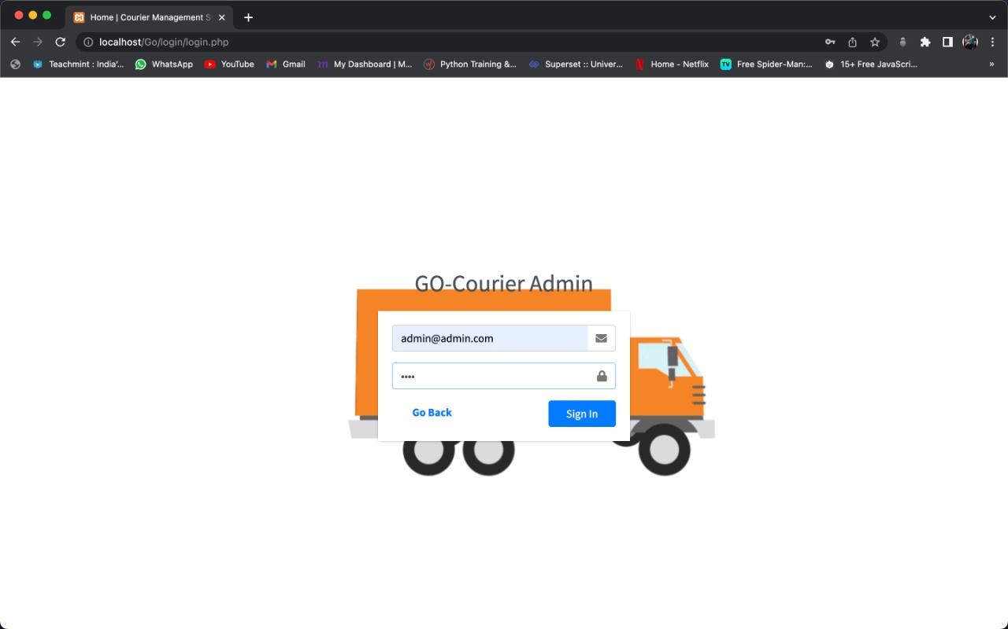

*Fig (10.2.1): login*

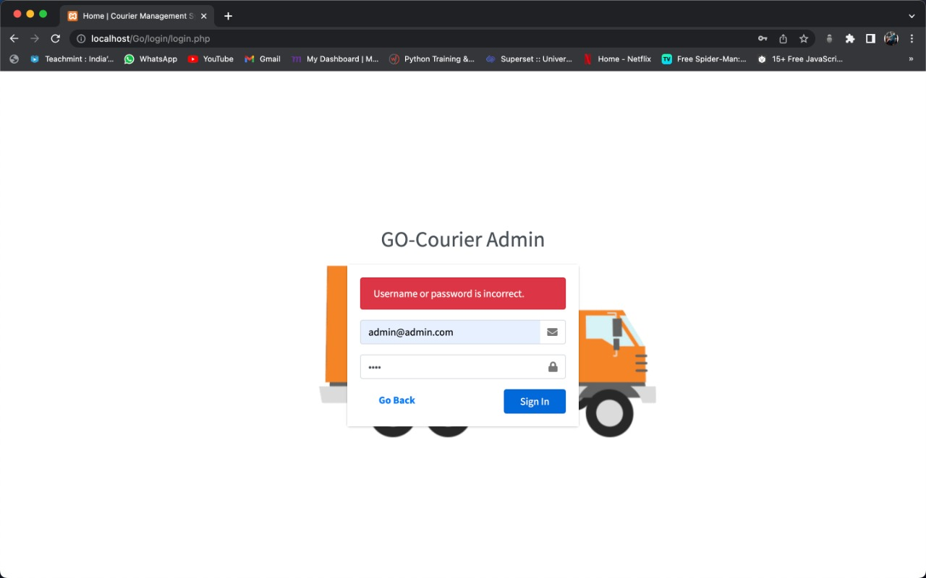

*Fig (10.2.2): login*

The above screenshot is showing the error message that we should enter valid username and password.

### BRANCH Table

Adding a new value to the table

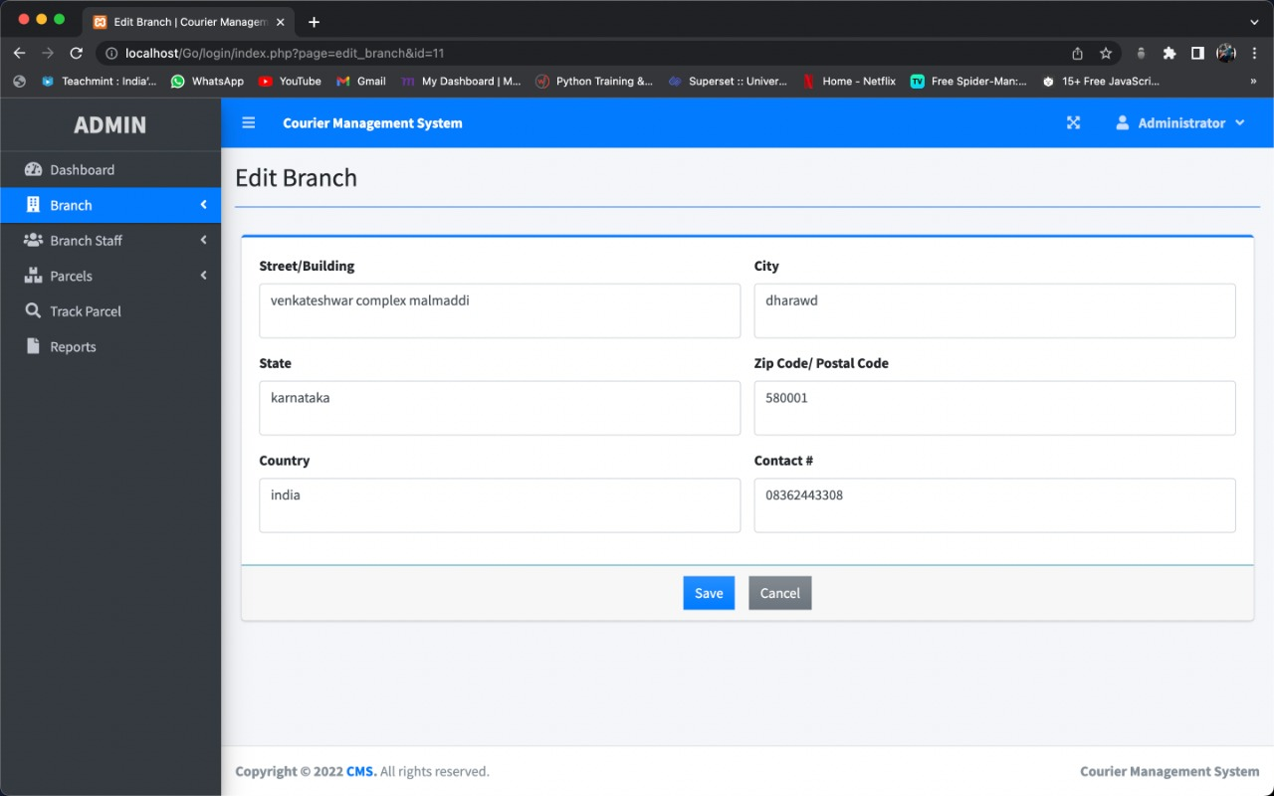

*Fig (10.2.3): Branch Table*

### Login Form

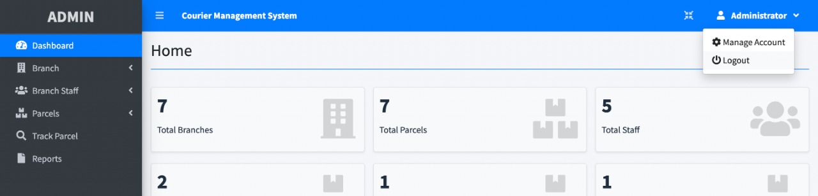

*Fig (10.2.4): Logout*

### STAFF DETAILS Table

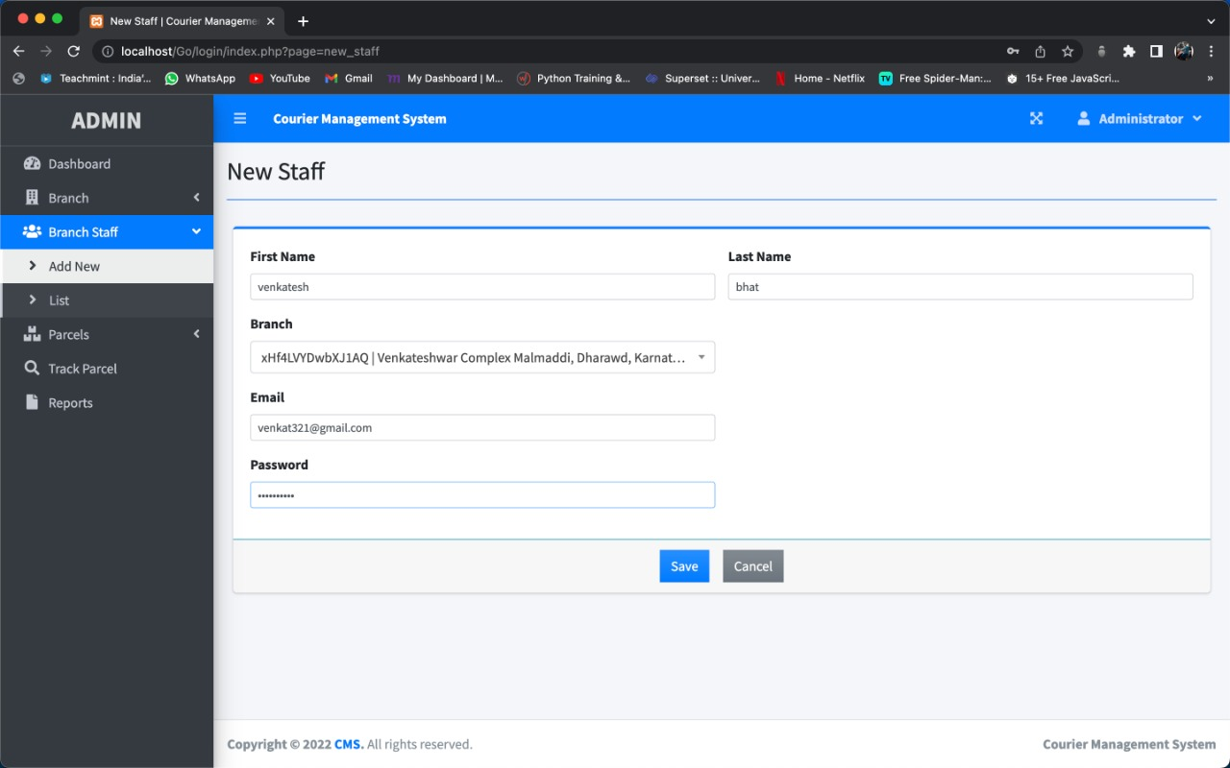

*Fig (10.2.5): Staff Details*

### PARCEL Table

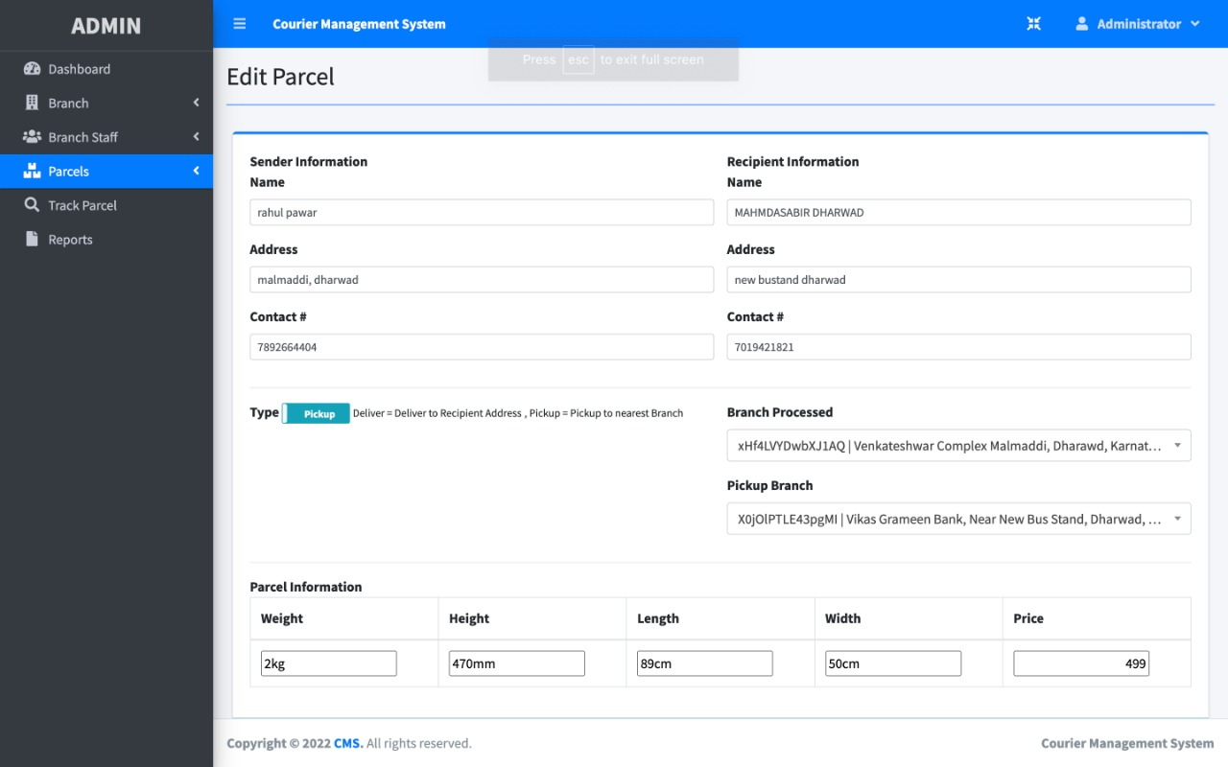

*Fig (10.2.6): Parcel table*

* 1. **Functional Testing**

|  |  |  |  |  |
| --- | --- | --- | --- | --- |
| **Test No** | **Test Case** | **Expected Result** | **Actual Result** | **Result** |
| 1 | Valid Username and Password | It should display respective page according to user type. | Respective Home is displayed | Fig  (10.2.1) |
| 2 | Invalid Username and Password | It should give appropriate error message saying “Enter proper User-ID and Password” | Error message displayed | Fig  (10.2.2) |
| 3 | Add/Update  /Delete  Member Details | Add/Delete/Update action is taken. | Added/Updated/Deleted Member message Displayed | Fig  (10.2.3) |
| 4 | Logout | It should logout correctly and should not go to the home page | Logout message displayed and login page is shown | Fig  (10.2.4) |
| 5 | Insert branch details | Choose branch name and branch address and submit the values | Values will be inserted in the table | Fig  (10.2.5) |
| 6 | Blank field while inserting | It should give appropriate error message | Display appropriate error message | Fig  (10.2.6) |

|  |  |  |  |  |
| --- | --- | --- | --- | --- |
| 7 | Valid FD details should be provided | It should insert the FD details into the database while inserting | FD details is stored while inserting | Fig  (10.2.7) |
| 8 | Insert values without notification status and submit | It must give an error message while inserting | Display appropriate error message | Fig  (10.2.8) |
| 9 | Insert values without account holder name and submit | It must give an error message while inserting | It will display the error message | Fig  (10.2.9) |
| 10 | Enter invalid mobile number | It should give appropriate message as “Mobile number entered is incorrect” | It will display the error message | Fig  (10.2.10) |

## 10.4 LIMITATIONS

* It varies time, cost and some risks.
* It uses internet.

## 10.5 SCOPE OF THE APPLICATION

* It takes very less time for completion of process.
* The application and requests can be verified by the admin wherever they are, and can take necessary actions.
* It is very easy for giving complaints and suggestions.

# CONCLUSION

Software is said to have attained its objective only when it need all requirements of the user, further the user himself is the person to judge the success of the system. Every attempt has been made to ensure that the system is fully functional and works effectively and efficiently. The system has been tested with simple data to cover all possible options and checked for all outputs. Since the system is flexible and modular, further modification of this packge can be easily incorporated.

### Importance of the system

* Less manual work.
* Increased efficiency.
* Decreases the rate of errors.
* It reduces the time consumption.
* Quick (instant) result.
  1. **Books**

# BIBLIOGRAPHY

* + 1. “Software Engineering”, by Ian Somerville, Sixth Edition, Pearson Education Ltd 2007.

### “Web Programming”, by ‘Chris Bates’ Wiley Dreamtech India, 2nd Edition.

* + 1. IEEE SRS Format.
    2. Database Management Systems, by Navathe.

# Websites

* + 1. <http://www.hotscripts.com/category/php/>for Php
    2. <http://en.wikipedia.org/wiki/PHP>**for Php.**
    3. <http://www.mysql.com/click.php?e=35050>for MySql.